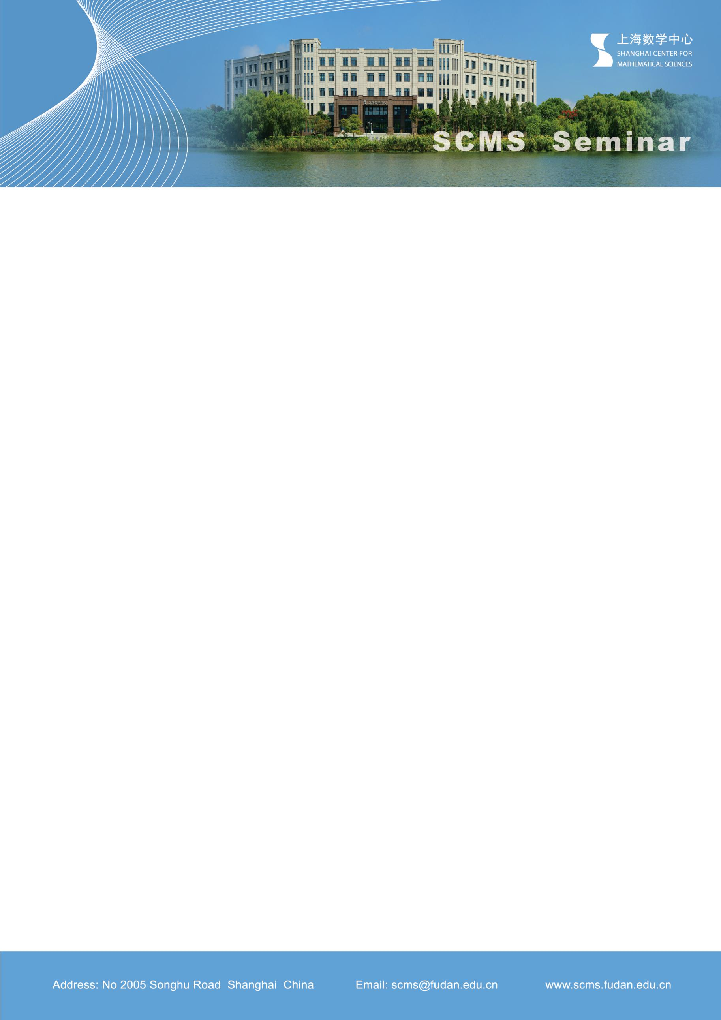

***Rigidity on hyperbolic invariant foliations***

**Speaker: Ruihao Gu**

**Shanghai Center for Mathematical Sciences**

**Time：Tue, Nov 26th, 13:30- 14:00**

**Venue: Room 102, SCMS**

**Abstract:**

In this talk, we introduce some rigidity phenomena on the invariant foliations of partially hyperbolic local diffeomorphisms, by focusing on properties of their transversals. Specifically, we show that matching the unstable foliations of two systems is equivalent to matching their Lyapunov exponents along the transversal. In particular, the $C^{2}$-smoothness of unstable foliation implies the constant Lyapunov exponents on the transverse direction and the higher regularity of the foliation.