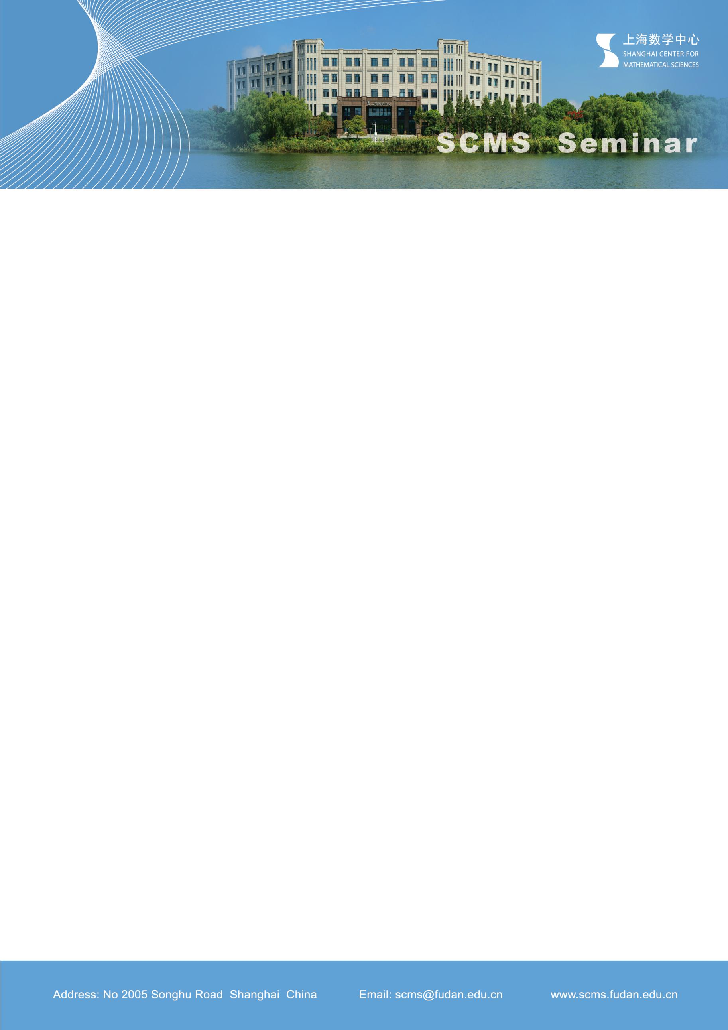

***Frostman-type lemma for modified lower box dimensions***

**Speaker: Shuqin Zhang**

**Shanghai Center for Mathematical Sciences**

**Time：Tue, Nov 26th, 14:00- 14:30**

**Venue: Room 102, SCMS**

**Abstract:**

Frostman’s lemma is a powerful tool in fractal geometry, which asserts the existence of measures of the type considered by the mass distribution principle. By the classic Frostman’s lemma, one can define the Frostman dimension for measures to approach Hausdorff dimension of a set. Cutler gave the Frostman-type lemma for packing dimensions in 1995. In this talk, I will review these Frostman-type lemmas applicable to different dimensions and present our results on the Frostman-type lemma for the Modified lower box dimensions. These results are based on joint work in progress with Amlan Banaji and Kenneth Falconer.